JUnit
Exercise 1: Setting Up Junit
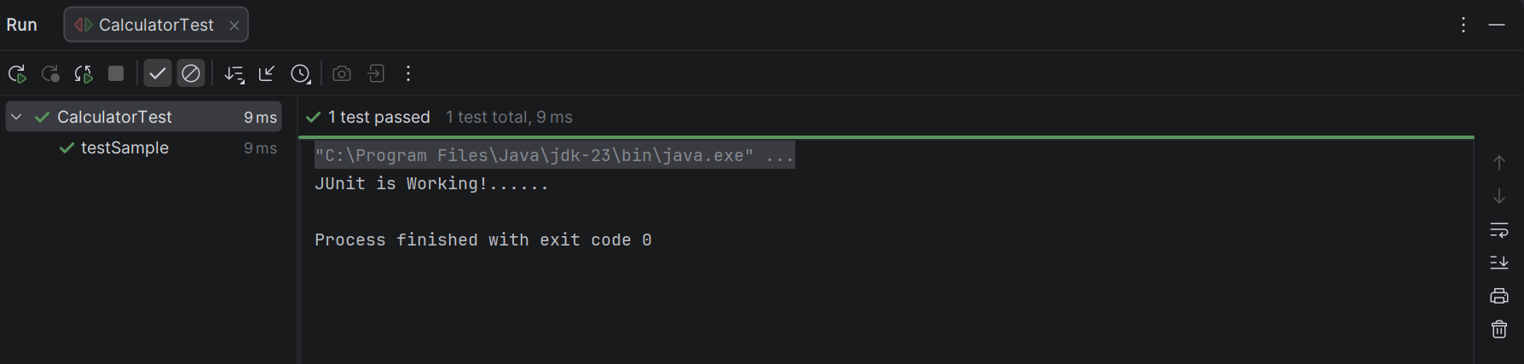

Exercise 2: Assertions in Junit
Correct Case:
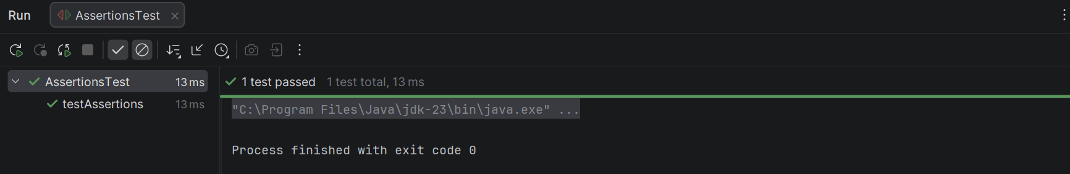
Wrong Case:
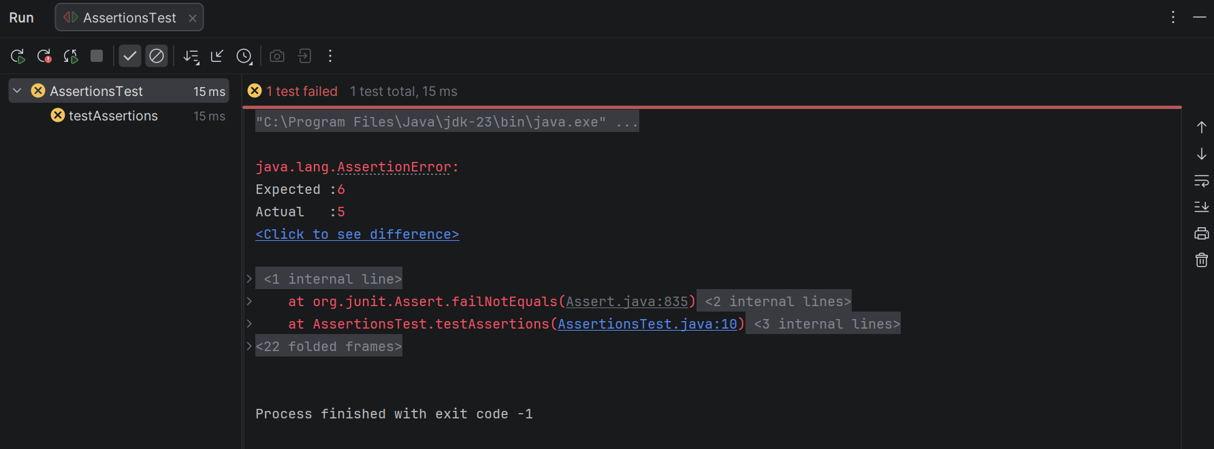

Exercise 4: Arrange-Act-Assert (AAA) Pattern, Test Fixtures, Setup and Teardown Methods in Junit
Output:
========== BEFORE TEST ==========
Initializing test data...
number = 5

----- ARRANGE -----
Value assigned = 5

----- ACT -----
Double of 5 = 10

----- ASSERT -----
Expected = 10
Actual = 10
Test Passed Successfully!

========== AFTER TEST ==========
Cleaning up test data...
number reset to 0
================================
========== BEFORE TEST ==========
Initializing test data...
number = 5

----- ARRANGE -----
Value assigned = 5

----- ACT -----
Square of 5 = 25

----- ASSERT -----
Expected = 25
Actual = 25
Test Passed Successfully!

========== AFTER TEST ==========
Cleaning up test data...
number reset to 0
================================

Process finished with exit code 0
